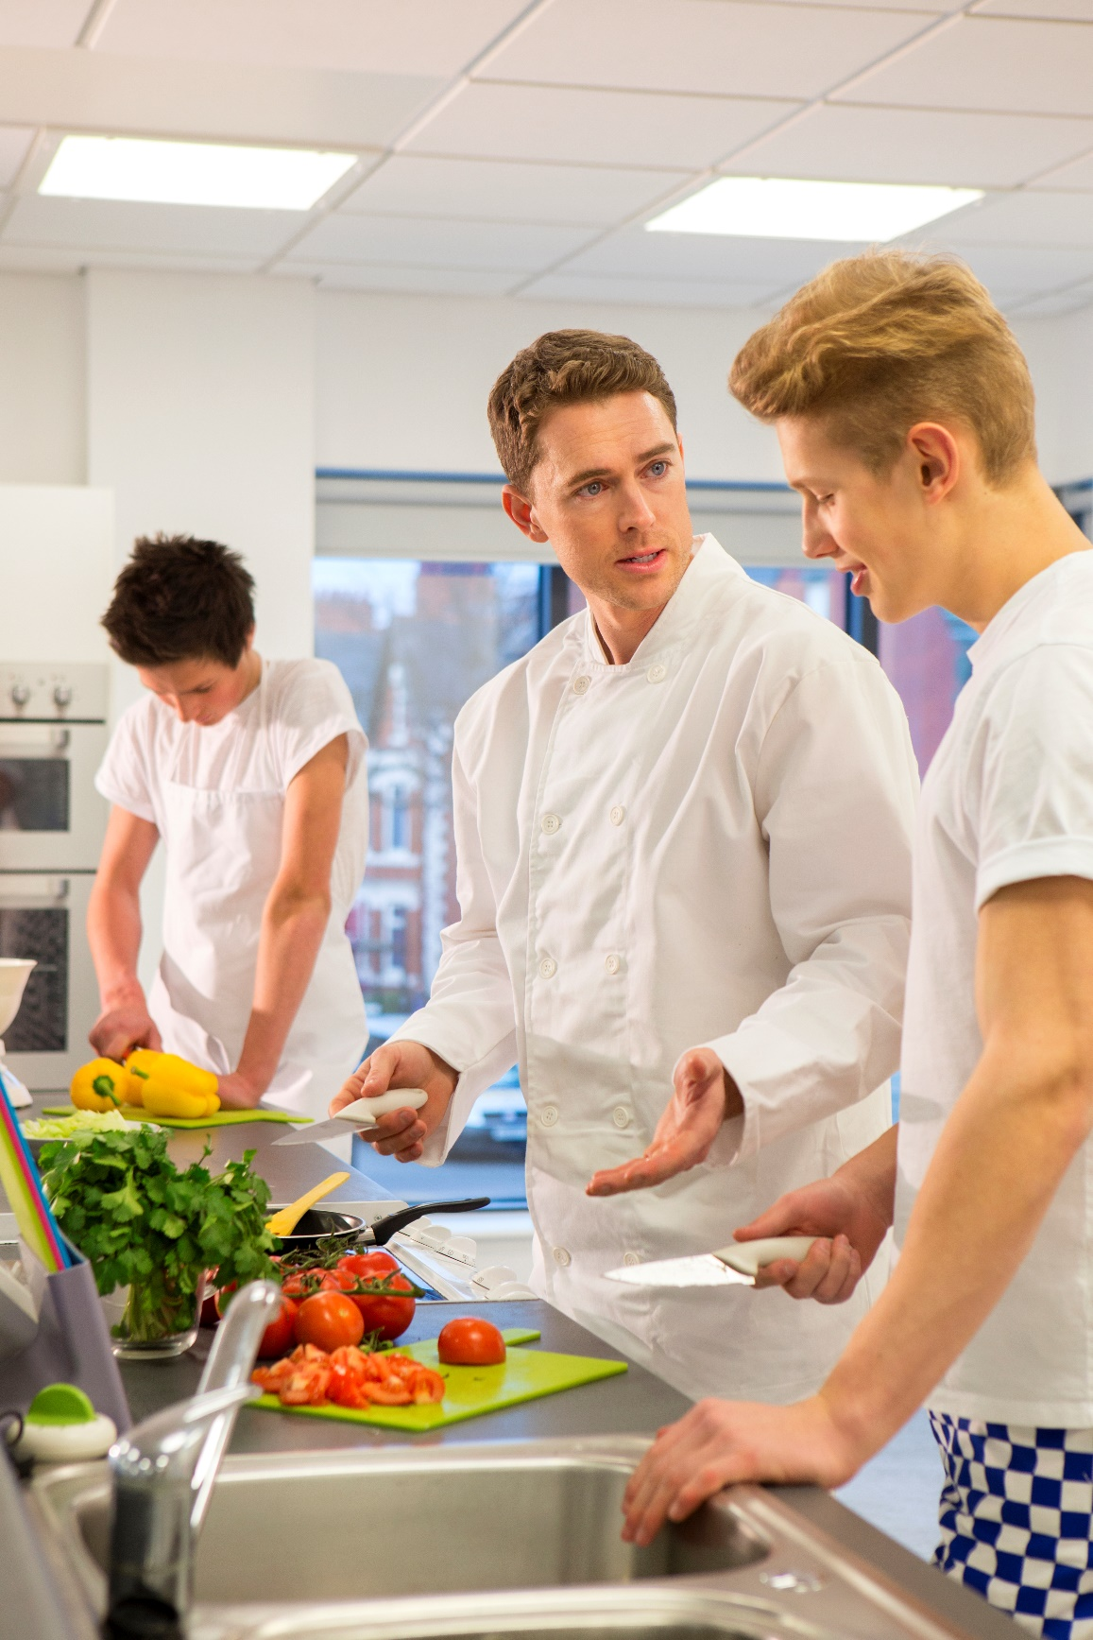

[Enter Restaurant Name]

Safety Policies
and Procedures

[Edition or publication date here]

[Restaurant Slogan Here]

THIS PAGE LEFT INTENTIONALLY BLANK

Table of Contents
Safety Policies and Procedures
Major Cause Of Food Borne Illness
- Always wash your hands after you
- Only Use Sanitized Equipment And Table Surfaces
- Avoid Cross Contamination From One Food Item To Another
- Store Foods And Equipment Properly
- When Cleaning Stationary Equipment
Preventing Falls
Preventing Electric Shock
Lift Properly
- Moving A Cart Properly:
Preventing Cuts
- Preventing Burns
- Preventing Fires
- Safe Chemical Handling
Reading the MSDS (Material Safety Data Sheets)

Safety Policies and Procedures
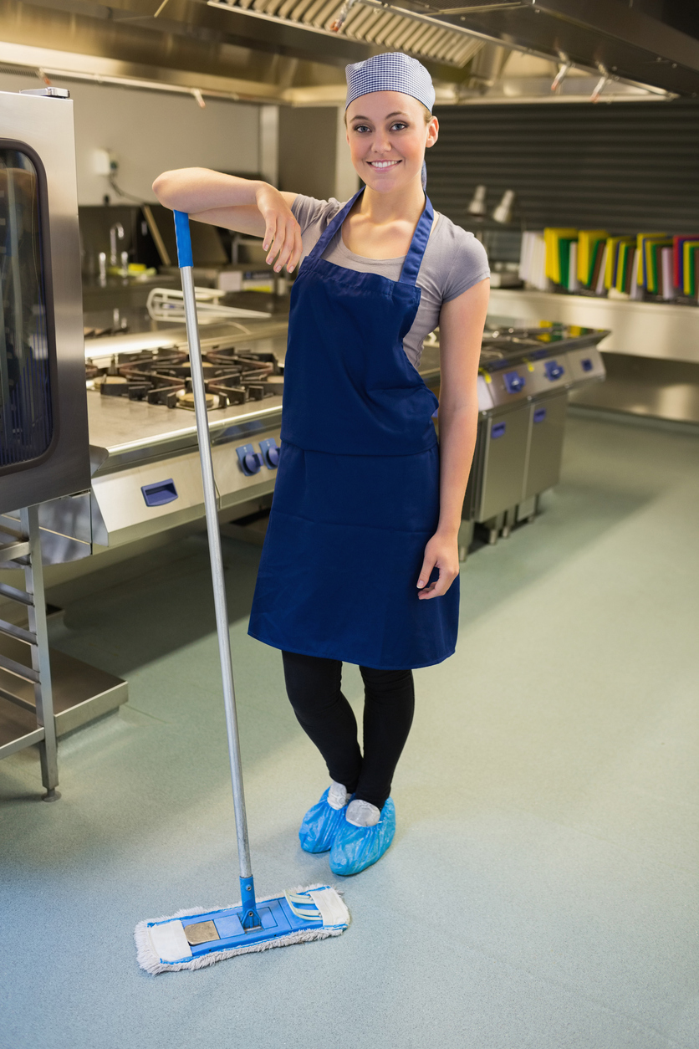
One of our primary goals at (RESTAURAURANT NAME) is to operate a sanitary, accident-free restaurant. A safe restaurant takes teamwork and effort on everyone's part. Everyone who works with cleaning chemicals will receive training on the use of those products and will be tested following the guidelines of OSHA Hazard Communication Standard, Title 29 Code of Federal regulations 1910.1200.
Safety meetings will also be used to review information presented from the initial training, and a safety representative will be selected for the Employee Associate Board of Directors. Management's role is to provide the daily monitoring of safe work practice developed from these meetings.
Whenever you see a potential hazard, or something you notice as unsafe, notify a manager immediately.
Here is a list of guidelines to follow for safety and sanitation:

Major cause of food borne illness:
Food left in the danger zone of 40° to 140° for four or more hours. Keep all foods out of the danger zone of 40° to 140°.
Keep hot foods hot, and cold foods cold.
Handle foods quickly during delivery and put refrigerated and frozen foods away as soon as possible.
Sloppy personal hygiene habits will not be tolerated.
Do not prepare food a day or more before serving.
Do not serve food that is not completely cooked.
Thaw foods in refrigerator, microwave, or under cold running water for not more than 2 hours, followed immediately by

Always wash your hands after you:
Smoke, eat, use the restroom; touch money, raw foods, or your face, hair or skin; cough, sneeze, or blow your nose
Comb your hair, handle anything dirty
Before and after taking a break

Avoid preparing food in advance, unless absolutely necessary.

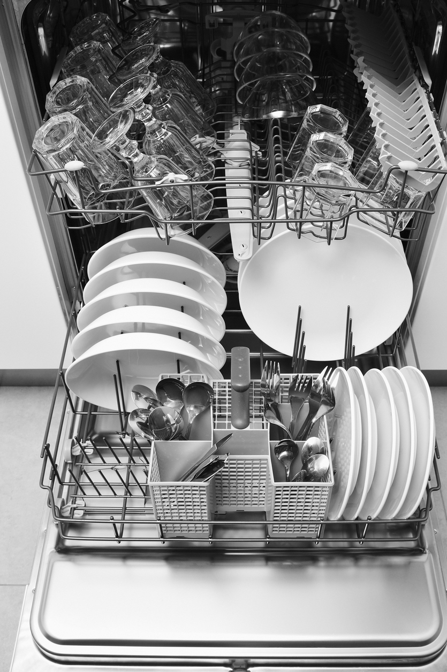
Inspect Foods thoroughly for freshness and wholesomeness upon receipt, cooking, and serving.

Only use sanitized equipment and table surfaces.

Dispose of waste properly:
- Take garbage out frequently.
- Keep garbage areas clean and sealed.
- Clean and sanitize garbage cans regularly.
- Store soiled linen in a laundry bag or non-absorbing container.

Keep insects and animals out by:
Keeping doors closed.
Taking garbage out frequently and keeping garbage areas clean.
Report any holes where an animal can enter.
Do not provide a free meal for any animals.

Handle ice and tableware properly:
Use clean scoops or tongs to pick up ice, do not use hands or glass.

Store scoops or tongs in a clean container, not in the ice.
Do not store any food or beverage in the ice.
Avoid touching food contact surface with dishes, utensils, etc.

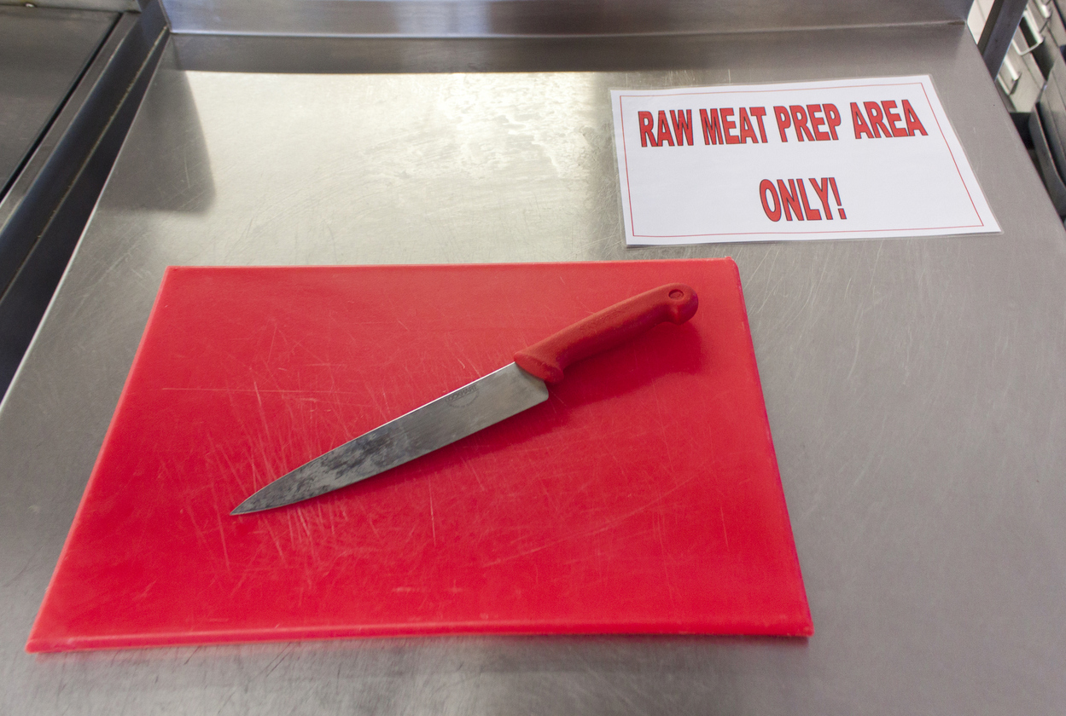
Avoid cross contamination from one food item to another:
Keep separate cutting boards for raw and cooked foods.
Never mix leftovers with fresh food.
Store fresh raw meats, poultry, and fish on lowest racks.
Sanitize thermometers after each use.
When thawing raw foods in the refrigerator, place them on the lowest shelf.

Store foods and equipment properly:
Cover, label, and date foods in storage.
Do not store food in open cans.
Store new foods behind old ones.
Store food off the floor and away from the wall.
Check temperatures of refrigerators and freezers daily.
Defrost freezers as necessary. Frost build up causes freezers to warm up.
Dry goods and storage areas should be cool and dry for good storage.
Do not store food or equipment under exposed server lines.
Keep storage areas clean.
Store all equipment so that dust cannot settle on it.
Store chemicals and pesticides separately from food.

When cleaning stationary equipment:
Unplug equipment, make sure hands are dry.
Disassemble.
Wash removable parts in dish machine, or three-compartment sink.
Wash and rinse stationary parts.
Sanitize food contact surfaces with sanitizer.
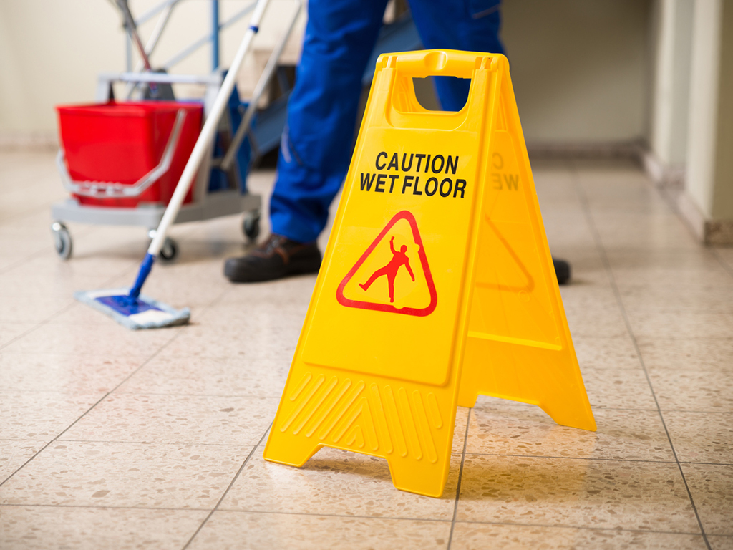
Air dry before reassembling, without touching food contact surfaces.

Preventing falls:
Wipe up spills immediately.
Use "wet floor" signs.
Wear shoes with non-skid soles and heels.
Keep isles and stairs clear.
Walk, do not run.
Follow established traffic patterns.
Do not carry anything that blocks your vision.
Keep drawers closed.
Use ladders properly; never use chairs, tables or boxes. Do not stand on top of ladder, and do not overreach.
Use handrails on stairs.
Turn lights on to see.

Preventing electric shock:
Never touch electrical equipment with wet hands, or while standing in water.
Unplug equipment before cleaning or disassembling, to avoid shock.
Do not yank plugs out by cord. This can cause damage to the cords, which may then cause shocks.
Report damaged and worn plugs and cords to your supervisor.

Lift properly:
Plan it. Do you need help? Could you use a cart? Where is it going? Which route is best?
Get ready. Spread feet apart, shoulder width. Put one food slightly in front of the other for a good support base. Squat down with back straight and head up. Do not bend over from the waist! Grip the object firmly with both hands. Keep elbows and arms close to body. Tuck in chin. If lifting a tray, squat down alongside the tray and slide the tray onto your shoulder and hand.
Lift it! Straighten your knees slowly and smoothly to a stand. Avoid doing this in a quick or jerky manner. Do not lift and twist at the same time.
Move it! Keep object close to you. To change position, move your feet and entire body. Do not twist from the waist. Look where you are going and call out "coming through" as needed.
Set it down! Bend your knees slowly and smoothly. Slide load into place; watch your fingers and toes.

Moving a cart properly:
Push rather than pull.
Spread feet wide, one in front of the other with your front knee bent.
Keep back straight.
Slowly push into the cart with your body weight, using your leg muscles to do much of the pushing.
Push slowly and smoothly. Avoid sudden motions or twisting your back.

Preventing Cuts:
Know how to operate equipment.
Pay attention when using sharp equipment. Never touch edges of sharp blades.
Use guards when provided on equipment.
Use tampers to push food into equipment.
Turn equipment off before adjusting.
No loose sleeves, ties, or dangling jewelry should be by equipment
Use knives carefully.
Carry dishes and glassware carefully.
Sweep up broken glass; do not use your hands.
Use special container to dispose of broken glass, dishes, and other sharp objects.
Remove can lids entirely from cans, then dispose of them.

Preventing burns:
Pay attention when working around hot equipment.
Use dry potholders.
Keep pot handles turned in from the edge of the range and open flames.
Avoid overfilling containers with hot foods.
Get help lifting heavy pots of hot foods.
Open lids of pots and doors of streamers away from you, and do so slowly, to avoid a steam burn.
Stir foods with long-handled spoons.
Warn others of hot surfaces.
Let equipment cool before cleaning, and do not use wet rags.
Do not put icy frozen foods into the fryer. Put foods slowly into the fryer and stand back to avoid being splattered.
Strike match before turning on gas equipment, to avoid a flare-up.
Wear closed-toe and closed-heel shoes that do not absorb liquids.
Warn guest of hot dishes.

Preventing fires:
Smoke only where allowed.
Do not turn your back on hot fat, as it may burst into flames.
Keep equipment and hoops from grease build up because grease causes many food service fires.
Do not set the fryer at too high a temperature.
Store matches in a covered container, away from heat.
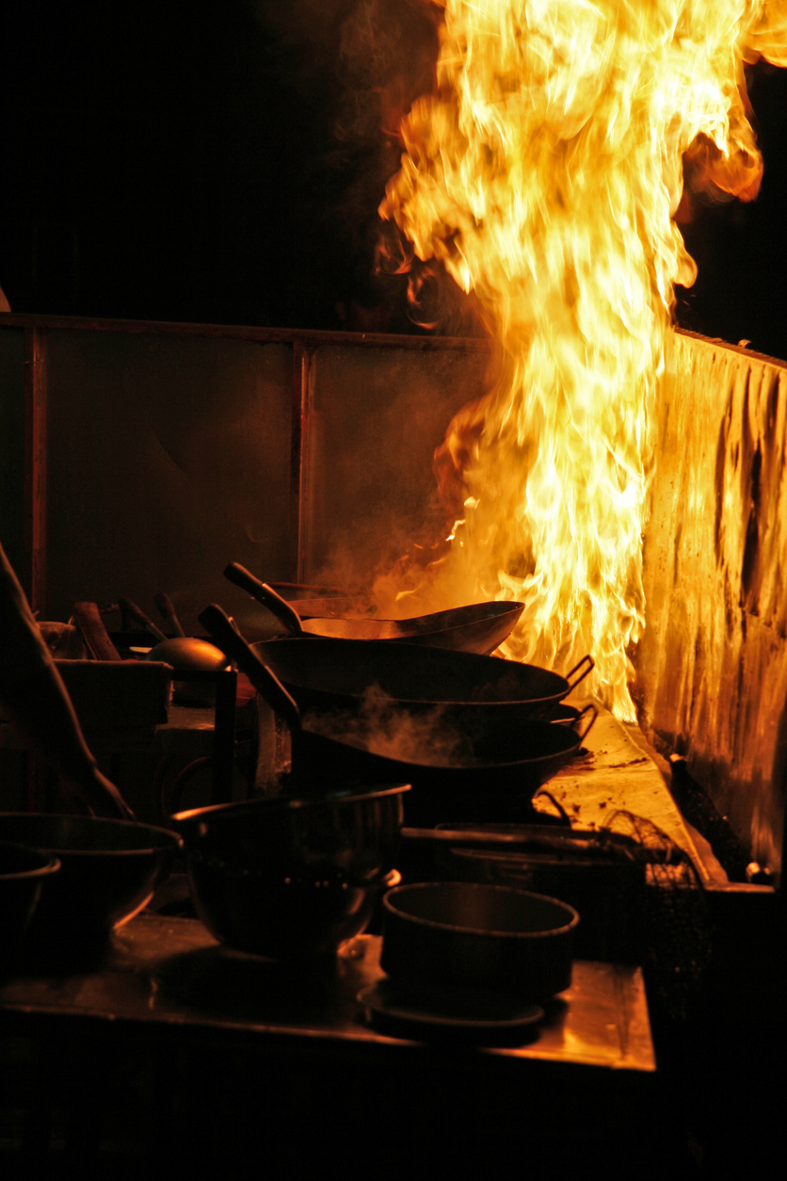
Keep garbage in covered container, away from heat.
Store chemicals away from heat because many chemicals are flammable.

Safe chemical handling:
Do know where the material safety data sheets are posted and read them.
Do read the labels of all products, before you use them.
Do follow the directions for proper storage, handling, and use for all chemicals you use.
Do ask your supervisor any questions or concerns you may have about using a certain products.
Do know how to call for medical help, in case of an emergency.
Do not ever mix chemicals together.
Do not store chemicals in unmarked containers.
Do not store chemicals in or close to food storage, preparation, or serving areas.
Do not leave aerosol spray containers near heat or spray close to an open flame.
Do not dispose of any empty chemical container until you have checked on the label for how to do so.
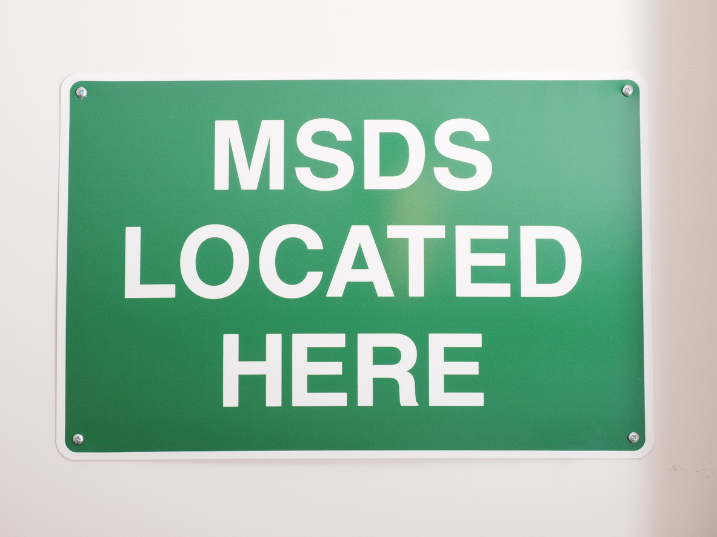

Reading the MSDS (Material Safety Data Sheets):
Read product name.
Fire hazard - explains if the product can catch fire or explode.
Health hazards - explains effects of over exposure and first aid procedures.
Spill precautions - explains steps to take in case of spills.
Special protection - describes any special measures, such as goggles and rubber gloves, used to decrease exposure and risk.

Reading product labels:
Read name.
Physical and health hazards.
Instructions for storing, handling, and use.
Instructions on what to do in case of an emergency.

