

Building Better Managers Webinar Resources
The following links provide access to the resources featured in the webinar, “Building Better Managers: Introducing the 11 Core Management Training Modules.”
# | Resource | Link/How to Access
 | 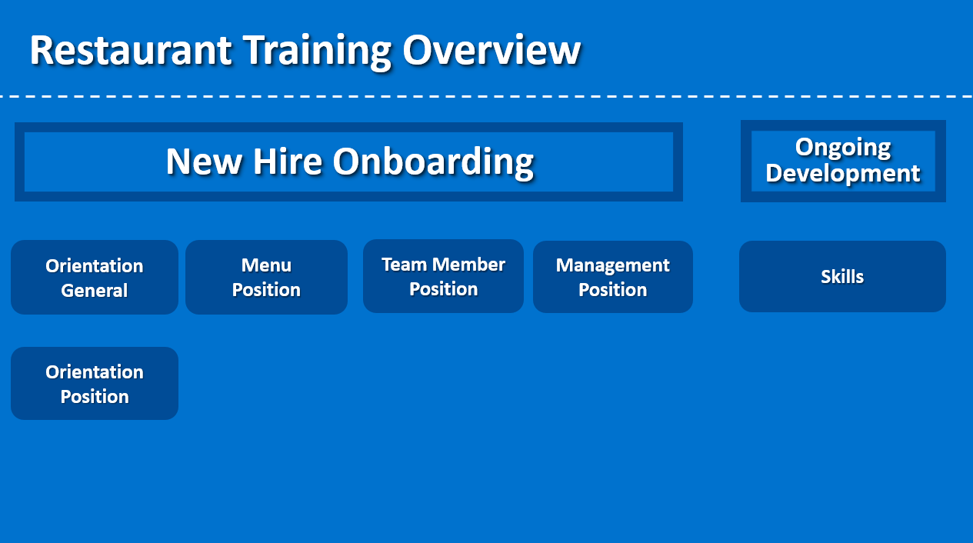 | Restaurant Training Overview Framework
 | 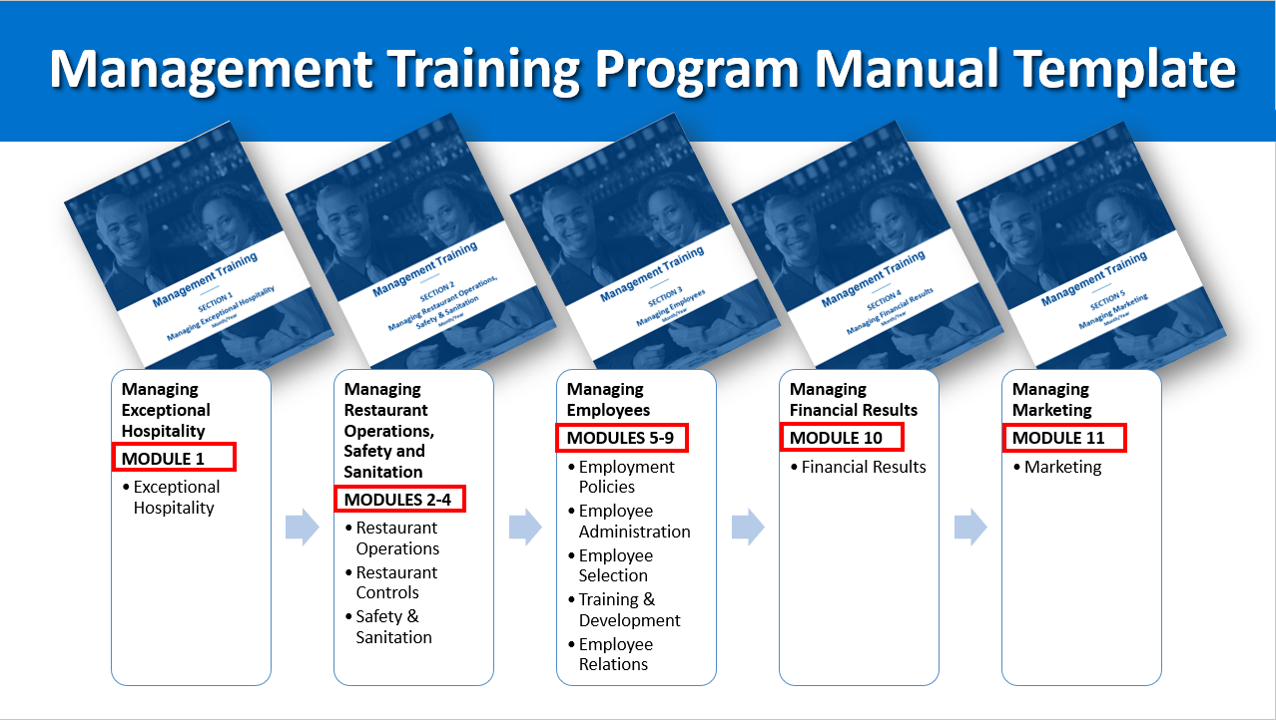 | Management Training Program Manual Template
 | 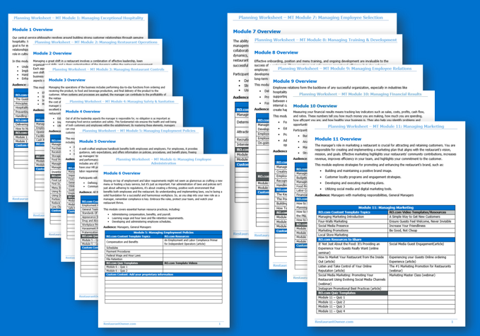 | To download the 11 Manager Modules: Restaurant Training: Management Position – Premade Planning Worksheets
 | 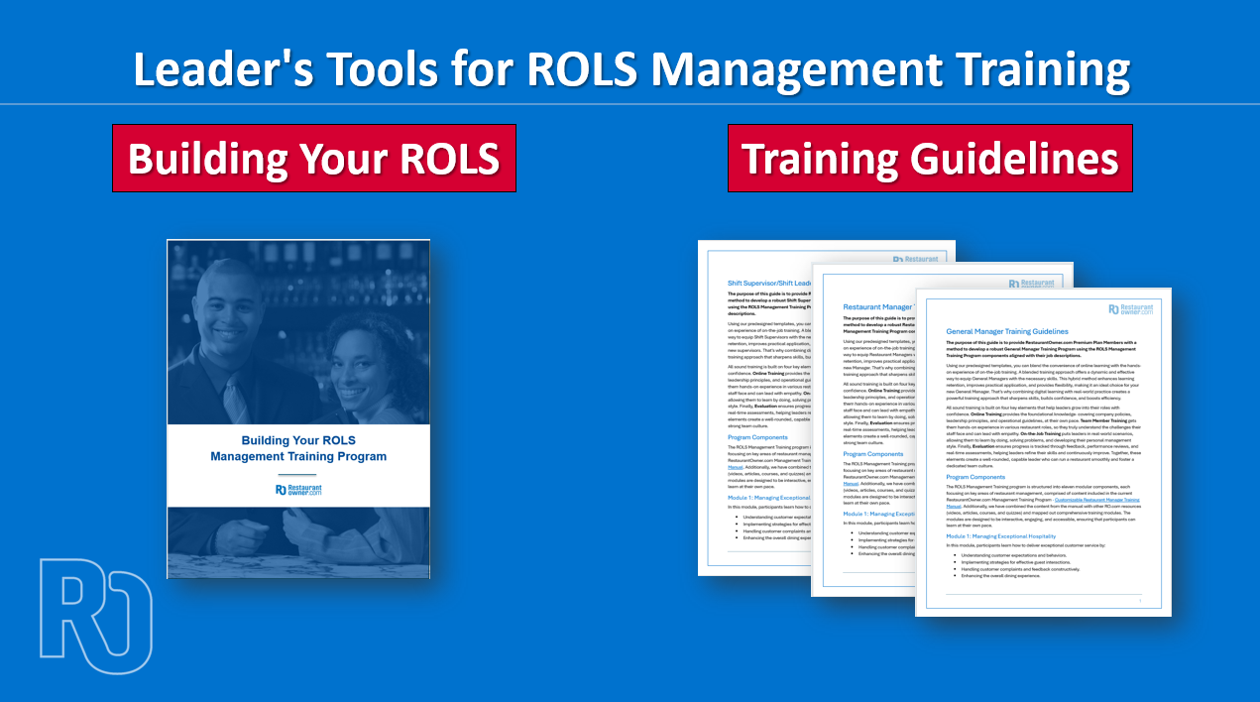 | Restaurant Training: Leader’s Tools for ROLS Management Training Program
 | 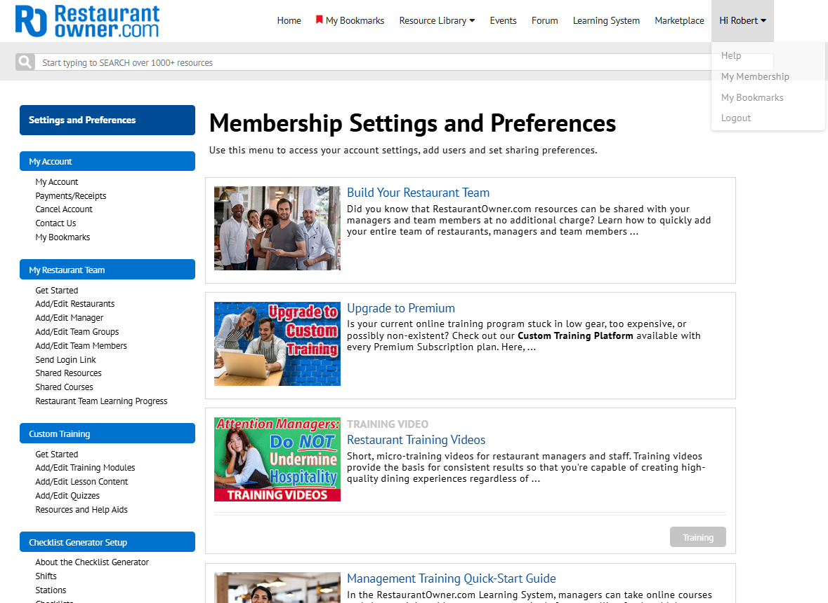  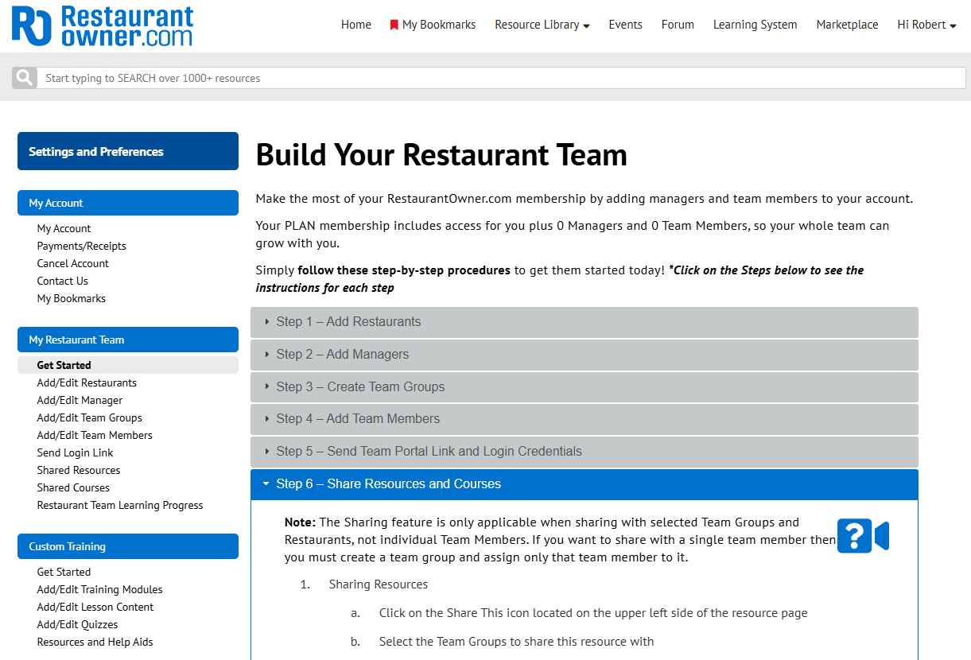 | To assign shared resources to your team:  Go to My Membership > My Restaurant Team and click Shared Resources to manage your shared resources.  If you would like to first watch a “How to” video on how to share resources to your team, please navigate to My Restaurant Team > Get Started. Select Step 6 – Share Resources and Courses and click on the camera icon in the top right corner.
 | 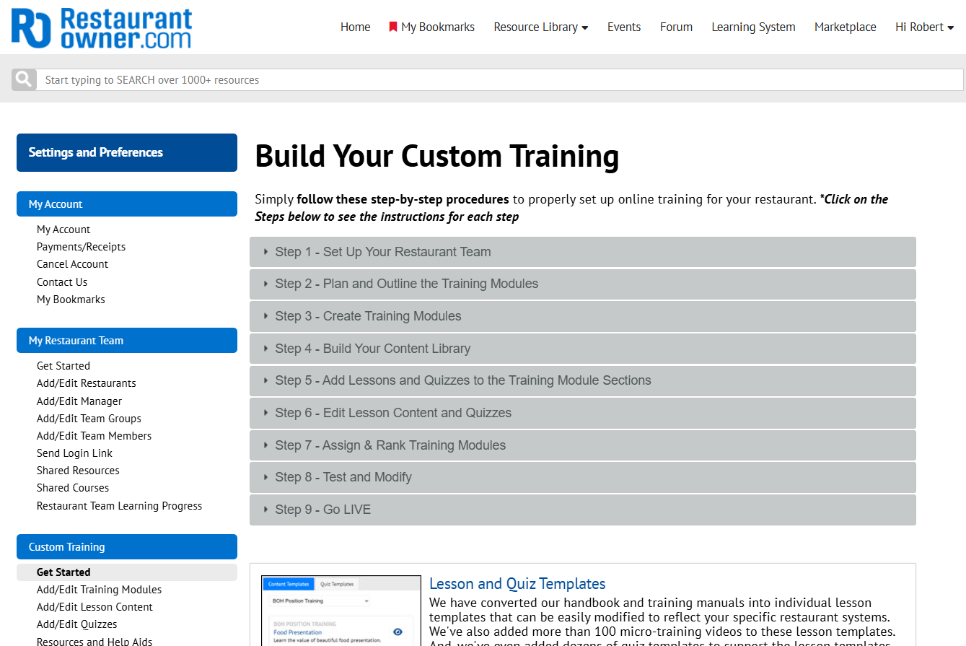 | To build your custom training modules:  Go to My Membership > Custom Training > Get Started. Simply follow these step-by-step procedures to properly set up online training for your restaurant.

