Photo Guidelines
A ‘good’ picture says a thousand words.

Photos are an integral part of marketing your restaurant not only to your customers, but also to your staff members.

Your photos must have Visual Appeal: High-quality images can make your food and drinks look incredibly appealing. When potential customers see mouthwatering, well-presented dishes, they are more likely to be enticed to order them.

Upselling: Great images encourage customers to order more. If they see a delicious dessert or specialty cocktail in an image, they might be tempted to add it to their order.

First Impressions: In today's digital age, many potential customers will encounter your restaurant online before they visit in person. Your website, social media profiles and online review listings create a positive first impression, giving people confidence in your establishment.

Trust and Credibility: High-quality images suggest professionalism and attention to detail. Customers are more likely to trust a restaurant that invests in its visual presentation.

Once you have great photos, you can use them in your social media posts, on your menus or table tents, review sites and in emails, and anywhere where you want to lure customers.

To get more of the solutions Bent shared on webinar, go to www.royaltyrewards.com/jim and request your free consultation call.

Drink and Food Photo Guidelines
Close Up Vertical Horizontal Vertical
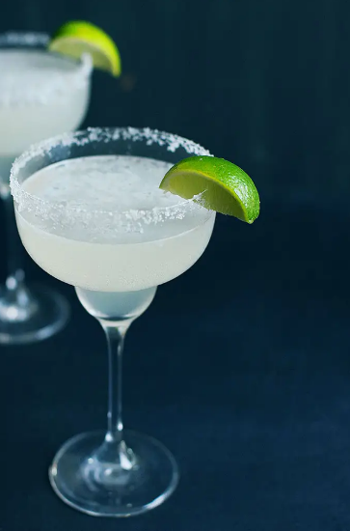
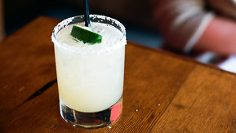
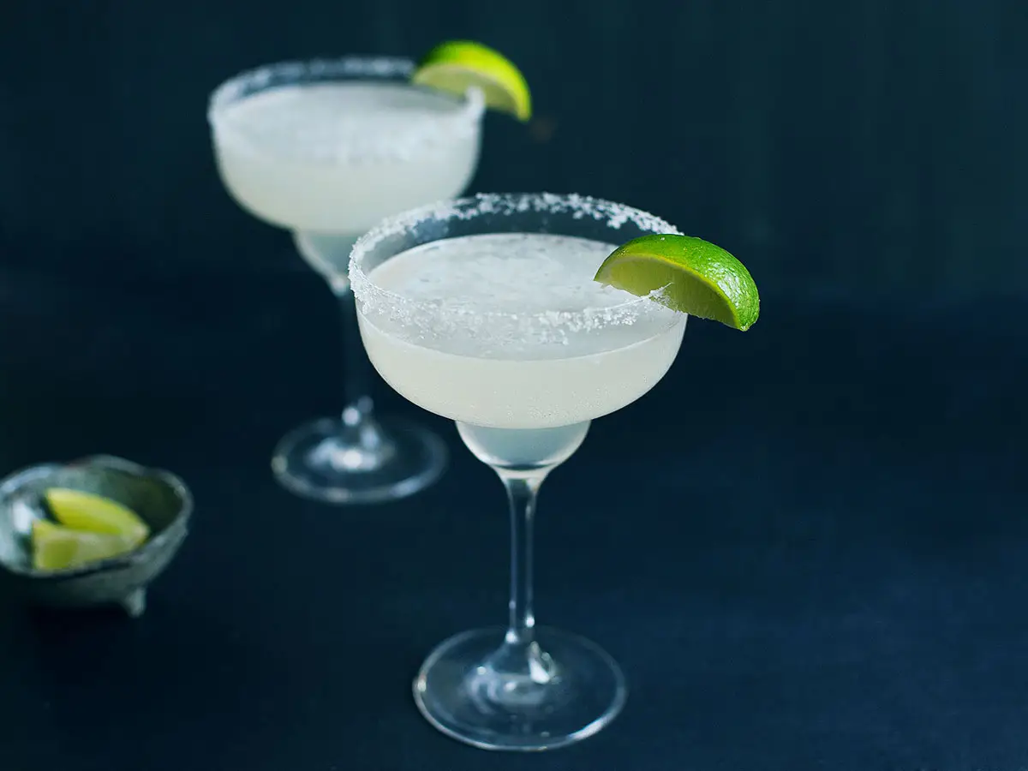
Leave Room For Text
Leave Room For Text
Leave Room For Text

*** One of each style of photo required***

Food Photo Tips
- Double check to make sure the dish looks right (side/garnish/etc)
- Lift the far side of the plate for better view (use napkins/coasters)
- Watch for dirty plate, extra splotches or something that doesn’t look right
- Watch for food drying up or changing while shooting. You can use a tiny bit of vegetable oil for a juicier look
Drink Photo Tips
- Double check to make sure the drink looks right
- Watch for major glare on drink glass (a slight shift of the camera will fix it)
- When shooting close up, shoot down to see the top of the drink
- Shoot straight across for vertical and horizontal images
Light 1

Light 2

Use the camera timer to help you hold the camera steady. Leave a little extra room on the edges, lights should be set at 5000k.

Item

Camera

Close Up Vertical Horizontal Vertical
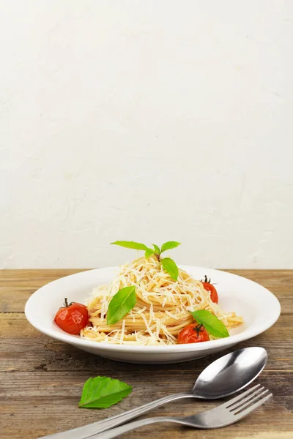
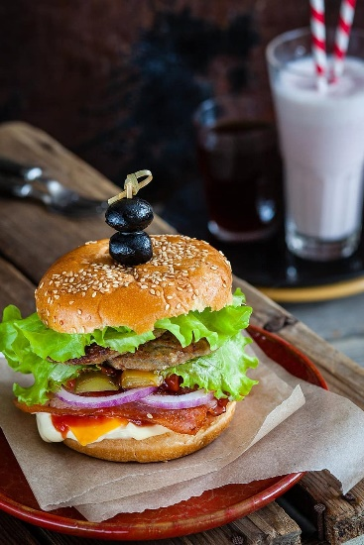
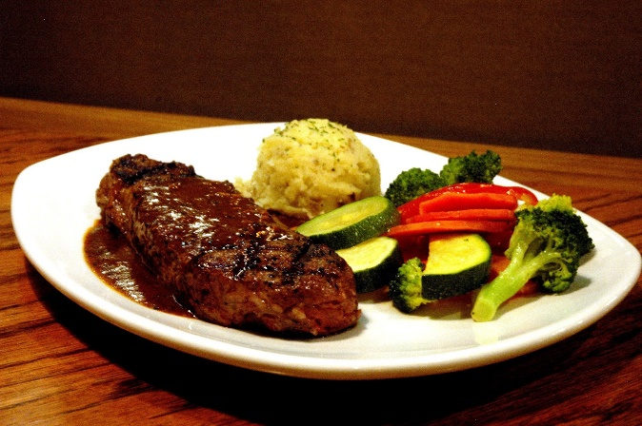
Leave Room For Text
Leave Room For Text
Leave Room For Text

*** One of each style of photo required***

