Highlighted Video Resources:

Purpose: Here is a list of resources recommended in the Webinar: “Exceptional Customer Service: Practice Ways to Boost Guest Delight & Increase Loyalty”
Topic | Video | Category
The Common-Sense Trap | 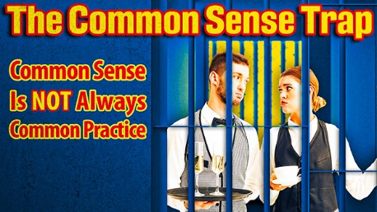 | FOH Training Video (4 min)
Order Taker vs. Experience Maker | 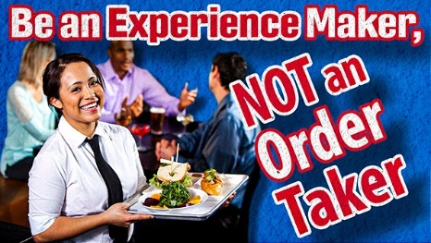 | FOH Training Video (5 min)
Impact of Emotions in the Guest Journey | 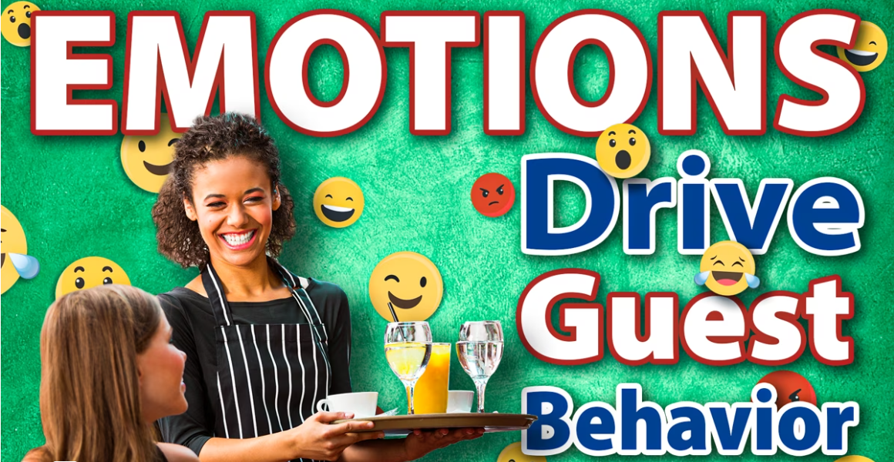 | FOH Training Video (3 min)
Two Dynamics of Customer Service | 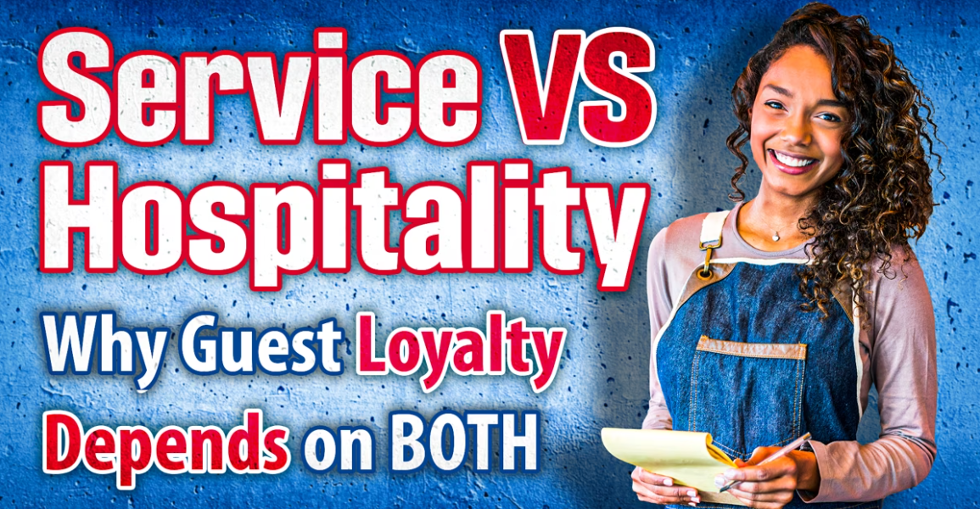 | FOH Training Video (3 min)
The Gift of Hospitality | 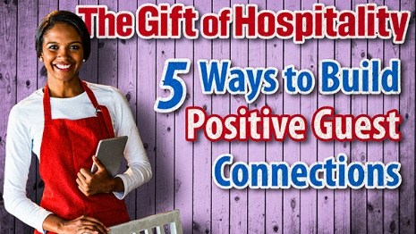 | FOH Online Learning Course (31 min)
Show Your Care | 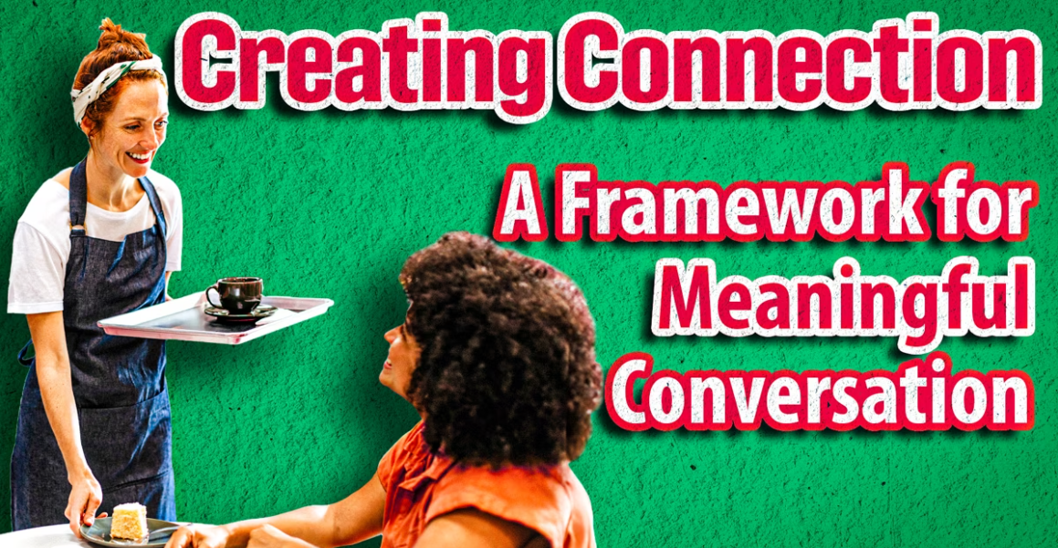 | FOH Training Video (6 min)
Power of Recognition Part 1 and Part 2 | 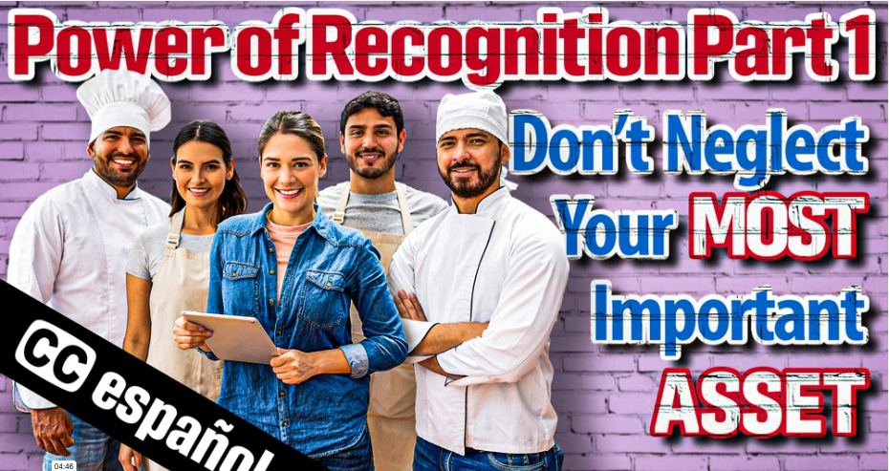 | MGMT Training Video  (5 min/3 min)
Circle of Hospitality (10/4 Rule): FOH |  | FOH Training Video (3 min)
Pre-Shift Meetings | 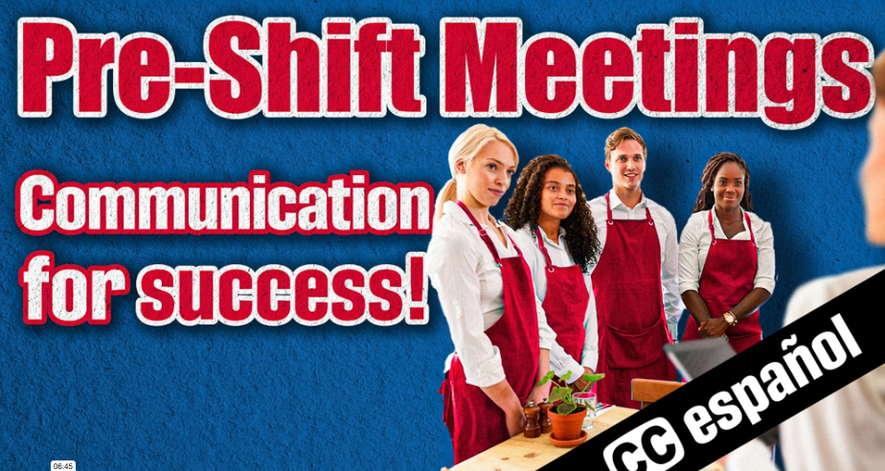 | FOH Training Video (7 min)
Last Impression |  | FOH Training Video (5 min)
Role-Play Video Series: “The Why” | 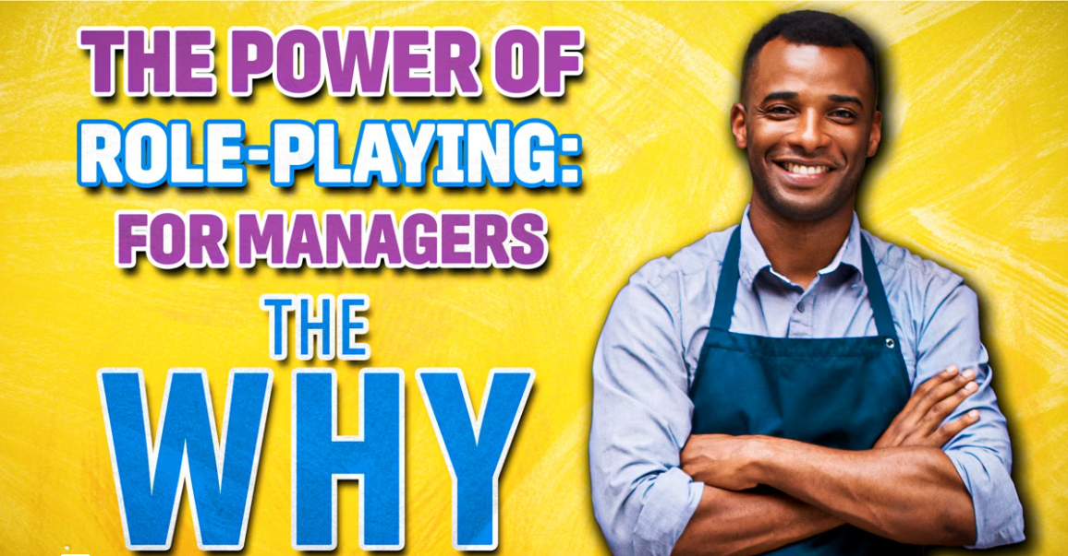 | FOH Training Video (3 min)
Role-Play Video Series: “The How” | 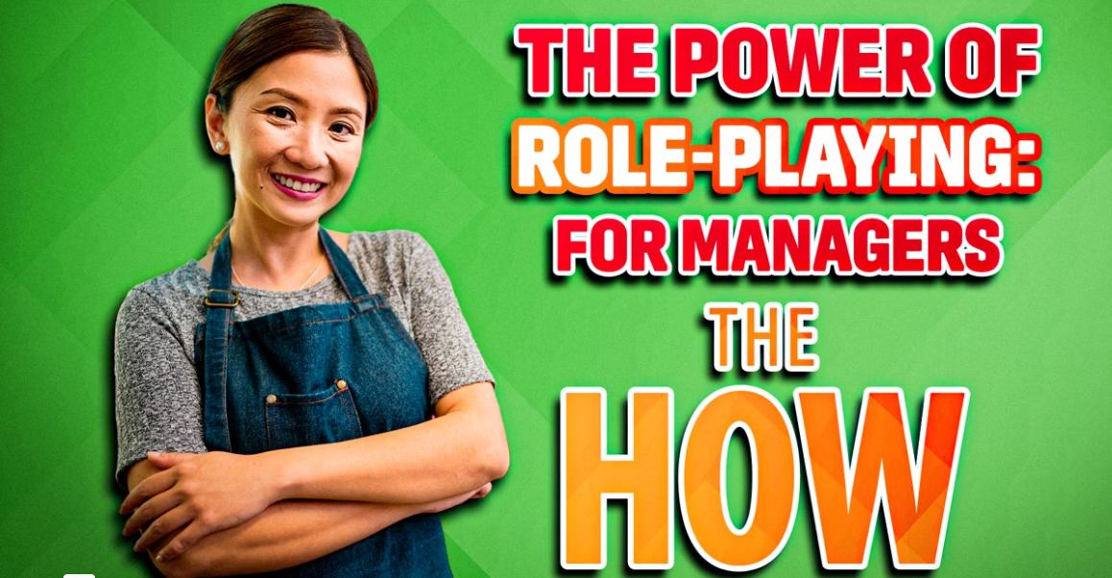 | FOH Training Video (7 min)
Role-Play Video Series: “Staff Video: Role-Playing Benefits” |  | FOH Training Video (4 min)
Menu Knowledge | 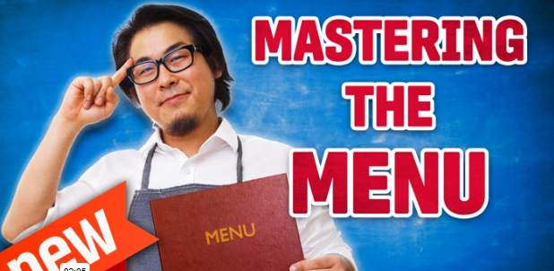 | FOH Online Learning Course (1 hour)
Steps for Seating Guests | 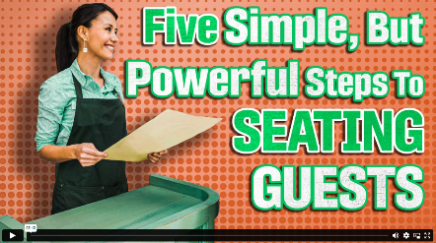 | FOH Training Video (6 min)

Additional Resources
RObi | 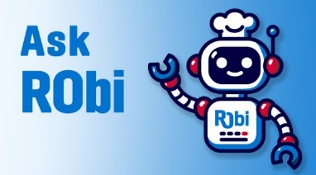
Getting Started with Training (LMS): Build Your Restaurant Team  Reach out to patricia@restaurantowner.com for a demo or support. | 

