CODE RED FORM

1. What Happened? |  | 2. What did you do?
INITIAL GUEST MOOD  Please check all that apply!  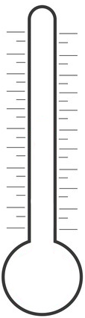  Food/Beverage  q Wrong product  q Items left off  q Not prepared right  q Wrong temperature  q Didn't taste good  q Foreign object  q Sold out  q Dirty tableware  q Other  Furious  Very Upset  Medium Upset  Annoyed  Calm  Happy  Facility  q Parking lot  q Dining room  q Restroom  q Other  (mark your response)  Service  q Long wait  q Didn't meet  expectations  q Other  Explain the key details that will help us learn from this and, if necessary, to follow up with guest: |  | After apologizing, what did you do to make it right?  q Replaced product  q Comped product  q Free drinks/appetizer/dessert  q Free entree'  q Discount  q Gift certificate  q Other (please explain)  FINAL GUEST MOOD  Furious  Very Upset  Medium Upset  Annoyed  Calm  Happy  Was management involvement needed? Y/N If yes, explain:
3. What follow-up is needed? |  | 4. What did it cost?
What further action should we take to go the “extra mile” for the guests? |  | Cost of Food/Beverage $_____________________  Labor $_____________________  Delivery $_____________________  Gift Certificate $_____________________  Refund $_____________________  TOTAL $_____________________
Guest Info (when appropriate) |  | Your Info
Name:________________________________ Phone:____________________  Address:_______________________________City:______________________  State:_____________ Zip:___________ Email:__________________________ |  | Name:_________________________________________________________  Incident Date_________________________ Time _______________am/pm  Location:_______________________________________________________

